sSAVED SEARCH FUNDAMENTALS
in NetSuite
Search Architecture, the Saved Search Definition Page, Criteria & Results Subtabs, Formulas, Permissions, and Sharing
Weekly Learning Series — Week 27

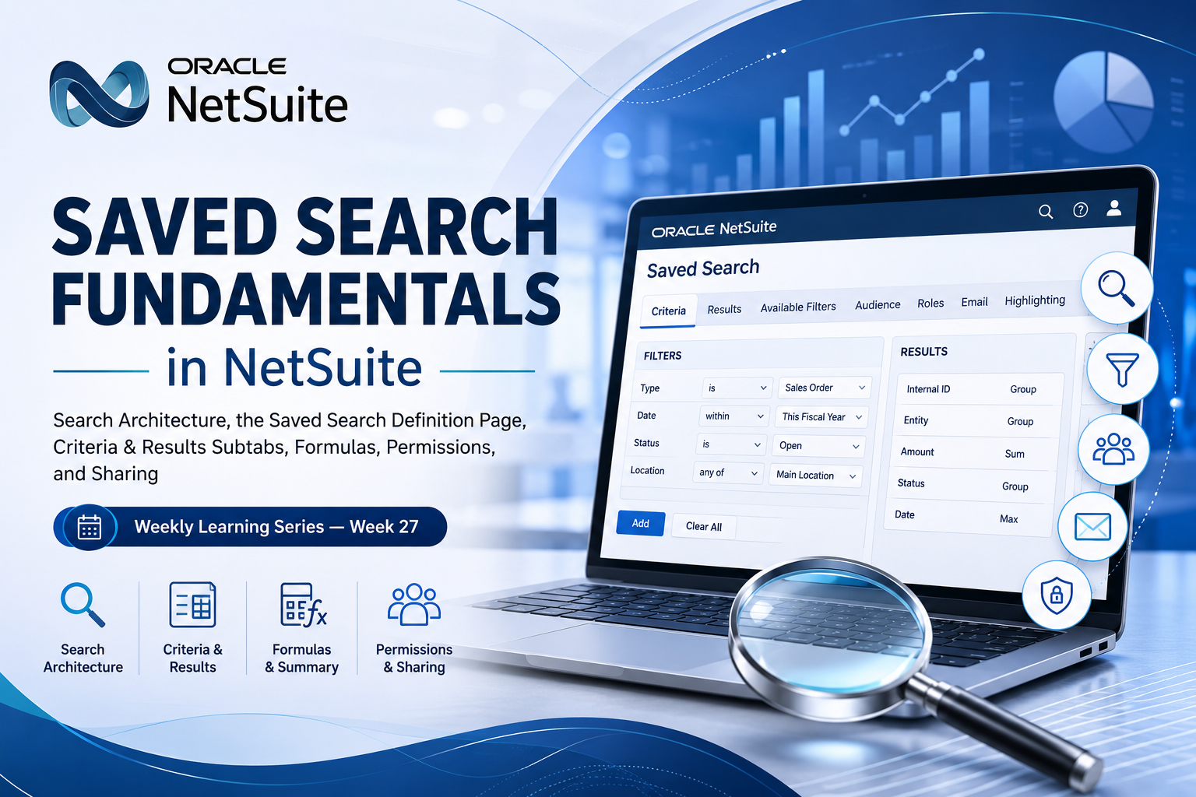

1. Introduction
Week 26 covered KPI Framework & Executive Dashboards — how a Center, a Dashboard, and portlets such as the Key Performance Indicators portlet, KPI Meter, Trend Graph, and KPI Scorecard surface business metrics on login, and how a Custom KPI is, at its core, nothing more than a saved search that satisfies a specific structural shape. That last point is the hinge for this week: a saved search is the reusable data-retrieval object underneath dashboards, reports, reminders, list views, and integrations alike. Before Week 28 goes deeper into advanced search techniques and performance, this week builds the foundation — what a saved search actually is, how its definition page is organized across the Criteria, Results, Available Filters, Audience, Roles, and Email subtabs, how formulas and summary types work, and which permissions govern who can create, run, share, and schedule one.
NetSuite's search capability is layered, not monolithic: a Simple Search filters on a handful of fields, an Advanced Search adds Criteria and Results subtabs with formulas and summarized results, and a Saved Search is a persisted, nameable, shareable superset of an advanced search that can additionally power KPIs, list and dashboard views, scheduled emails, and reminders. This document works through that full definition page, subtab by subtab, so the mechanics behind every saved search — including the ones already powering Week 26's Custom KPIs — are explicit rather than assumed.
📌 Why a Saved Search Isn't Just "a Filtered List"
- A saved search is a named, persisted object with its own record: it can be owned, shared to an audience, scheduled to email results, used as a dashboard or list view, and referenced as a Custom KPI — none of which an ad hoc advanced search supports.
- The same three subtabs that shape a search's data — Criteria, Results, and Available Filters — are exactly what Week 26 relied on to define whether a search qualifies as a Custom KPI; saved search fundamentals and KPI fundamentals are the same underlying mechanism viewed from two angles.
- Five Lists-type permissions (Perform Search, Publish Search, Persist Search, Export Lists, Tableau Workbooks Export) independently govern running, saving, sharing, scheduling, and exporting — a user can often run a search without being able to save, share, or schedule one.

2. Search Architecture — Simple, Advanced, and Saved Searches
Every NetSuite search page is built for a specific record type and offers the same two entry points: a Simple search, where you enter one or more field values to filter results, and an Advanced search, where you can add more filters, use formulas with SQL expressions, filter by related records through joins, set sort order, and group results with summary calculations. Whichever mode you used last for that record type is the one that opens by default; checking or clearing Use Advanced Search toggles between them.

Mode | What It Adds | Access Point
Simple Search | One or more field values as filters; fastest way to narrow a list. | Reports > New Search, or most list/search menu links (opens whichever mode was used last).
Advanced Search | Criteria subtab (filters, joins, formulas, expressions) and Results subtab (display, summary types, sort). | Check Use Advanced Search on a simple search page.
Saved Search | Everything Advanced Search does, plus persistence, an owner, Audience/Roles sharing, Email alerts and schedules, Available Filters, Highlighting, and eligibility as a Custom KPI. | Click Create Saved Search from any simple/advanced search or results page, or go to Reports > Saved Searches > All Saved Searches > New.

In practice, a saved search is not a separate query language — it is the same Criteria/Results mechanism as an advanced search, wrapped with a title, an owner, a Public flag or Audience definition, and a set of additional subtabs. Anything you can express in an advanced search's filters and formulas carries over unchanged the moment you click Create Saved Search.

3. Anatomy of the Saved Search Definition Page
A saved search definition page is reached from a search results page, from an advanced search's Create Saved Search button, or directly at Reports > Saved Searches > All Saved Searches > New. The page is organized into a header section and a series of subtabs; the header alone controls how the search behaves as a menu item, a view, and a reminder source before any filter is even defined.

3.1 Header Settings
- Title — kept short and meaningful, since it can surface as a menu link, a dashboard portlet header, or a Custom KPI name.
- Owner — defaults to the creator; changeable by administrators, or by the owner if the search is public or has an audience defined. Reassigning the owner of a scheduled search to someone who has never scheduled a search before silently stops the scheduled email until the new owner re-saves it.
- Public — available only to administrators and users with at least Create-level Publish Search; makes the search runnable and viewable by all users, though only administrators and the owner can edit it unless Allow Audience to Edit is checked on the Audience subtab.
- Available as List View / Dashboard View / Sublist View — lets the search's results stand in as a view for the searched record type's list pages; each can be restricted to specific users via the Roles subtab instead.
- Available for Reminders / Show in Menu — controls whether the search can back a Reminders portlet link, and whether it appears in the saved search menus at all.

3.2 The Criteria Subtab — Standard and Summary Filters
The Criteria subtab has a Standard sublist and a Summary sublist. A standard filter finds results based on each record's own field value — a field from the record type itself, a join field from a related record type (listed with '...' after the related type's name), a formula, or a file-attachment field. A summary filter, by contrast, finds results based on a calculated summary value for a group of records, and only becomes available once a field has been given a summary type on the Results subtab.
- Select a field from the Filter dropdown, then use the Set Description popup to enter a value and search logic.
- For a join field, select the related record type (marked with '...'), then choose the specific join field in the popup that follows.
- For a formula filter, choose a Formula option from the Filter dropdown and enter the expression in the Set Description popup — see Section 4.
- Check Use Expressions to combine multiple standard filters with parenthetical AND/OR logic rather than NetSuite's default implicit AND.
⚠️ Date Filters and Custom KPI Eligibility Are Decided Right Here
- If more than one date filter is set on the Criteria subtab, the one with the most recent date is used to calculate exchange rates, regardless of the order the filters are listed in.
- As Week 26 covered, a saved search intended for use as a Custom KPI across multiple date ranges must NOT include any date field as a Criteria filter — that date scoping instead belongs on the Available Filters subtab (Section 3.6).

3.3 The Results Subtab — Display, Columns, and Drill Down
The Results subtab controls what the search shows and how. Its header holds page-level settings; the Columns sublist controls the fields themselves; an optional Drill Down Fields sublist (visible only with the Presentation Categories permission) controls what appears when a viewer drills into an individual record from the results.
Header Setting | Effect
Sort By | Sets the sort order of result rows. A saved search needs at least one sort order; if none is set, the first Columns-sublist field is used.
Output Type | Overall results format: Normal, Report, Grid, or Graph.
Show Totals | Adds a total line to the results page.
Run Unrestricted | Shows results to users who'd normally be restricted from the underlying records — subject to Restrict Time and Expenses overriding it for time/expense data, and to the viewer still needing basic permission to see results at all.
Disallow Drill Down | Blocks users viewing unrestricted results from drilling into full record detail.
Max Results | Caps how many records the results page returns.
On the Columns sublist, each field can carry a custom label (with translations), a summary type to roll up a group of records, and a function applied to its value; column order there also sets the default drill-down field order and, absent an explicit Sort By, the default sort field.

3.4 Summary Types — Rolling Up Search Results
Group is the summary type that does the rolling up; every other summary type on the Results subtab needs a Group summary set on some field before it produces meaningful rollups. Once a Group is defined, Count, Sum, Minimum, Maximum, and Average can each be applied to other columns for that group.
Summary Type | Purpose | Example (Sales Order Search)
Group | Rolls results up by the field it's applied to; some field types can't be grouped. | Group transactions by customer name.
Count | Counts the results in the group for that column. | Count items purchased per customer.
Sum | Adds up the column's values for the group. | Sum sales order amounts per customer.
Minimum | Shows the smallest amount, or earliest date. | Smallest transaction amount per customer.
Maximum | Shows the largest amount, or most recent date. | Largest transaction amount per customer.
Average | Averages the column's values for the group. | Average transaction amount per customer.

This same rule — one summarized field, everything else riding along at group level — is exactly the shape a Custom KPI's saved search must have, as covered in Week 26: exactly one Results field carrying a summary type, with every other Results field carrying none.

3.5 Highlighting, Available Filters, Audience, Roles, and Email
- Highlighting subtab — applies images, colored text, background colors, or bold formatting to individual or aggregated results that meet a condition, so exceptions are visible at a glance.
- Available Filters subtab — defines extra, optional filters — beyond the Criteria subtab's fixed filters — that viewers can apply dynamically from the results page, as a single-select dropdown (default) or, with Show as Multi-Select checked, a multi-select box. Show in Filter Region controls whether the filter appears on the results page at all; a date field placed here without that box checked is exactly the setup Week 26's Custom KPIs depend on for multi-period comparisons.
- Audience subtab — available with at least Create-level Publish Search; defines who can run and view the search by Internal/External Roles, Departments, Subsidiaries, Groups, Employees, or Partners. Choosing both a role and a department requires matching both to qualify; any other combination only requires matching one.
- Roles subtab — also gated by Publish Search; controls where the search's results appear as the record type's default view — lists, sublists, dashboard list portlets, forms, and quick search results — per role.
- Email subtab — gated by Publish Search; supports alert emails on record create/update, scheduled emails on a recurring interval, or both, with recipients defined per option and an optional Public and Allow Users to Subscribe setting so others can opt in from Home > Set Preferences.

3.6 Saving and Running
- Preview — runs the search and shows results without saving anything.
- Save — persists the definition so the owner and any audience members can run it.
- Save & Run — saves the definition and immediately displays results.
- Save & Email — saves the definition and emails results to the recipients set up on the Email subtab's Specific Recipients sublist; requires the Publish Search permission.

4. Formulas in Searches — the Basics
Formulas can appear in three places: as part of a custom field whose value is itself formula-driven (usable afterward like any other field), as a Criteria-subtab filter whose match is based on the formula's calculated value, or as a Results-subtab column whose displayed value is the formula's calculated value. A formula definition can reference NetSuite field IDs (substituted with each record's value), SQL functions, and mathematical operators, and is recalculated dynamically every time the search runs.
Variable | Synonym(s) | Returns
{today} | {now} | Current date, per the user's time zone and formatting.
{me} | {user}, {user.id} | Current user's internal ID.
{userrole} | {userrole.id} | Current role's internal ID.
{user.department} | {userdepartment.id} | Current user's department ID.
{user.location} | {userlocation.id} | Current user's location ID.
{user.subsidiary} | {usersubsidiary.id} | Current user's subsidiary ID.
{user.class} | {userclass.id} | Current user's class ID.
{usercurrency} | {usercurrency.id} | Current user's currency.

{today}-{startdate} as a results column returns a case's number of days open, and ({today}-{startdate}) > 3 as a Criteria filter returns only cases open more than three days.

⚠️ Formula Pitfalls Worth Knowing Before Week 28's Deep Dive
- Aggregate and non-aggregate SQL functions cannot be combined in a single formula definition.
- Formulas should reference internal field IDs rather than translated display values — a formula built against an English label can return different results for a user with a different language preference.
- Encrypted fields such as credit card numbers and Social Security numbers cannot be used in formulas at all; doing so raises an invalid expression error because SQL cannot decrypt them.
- Formula (Text) results render as plain text only for security; Formula (HTML) requires both the HTML Formulas in Search feature and the Create HTML Formulas in Search permission.

5. Permissions Governing Saved Searches
An administrator assigns roles, and each role carries its own search-related permissions. Five Lists-type permissions specifically govern what a role can do with searches and saved searches:
Permission | Levels | What It Controls
Perform Search | View, Full | View: run searches/saved searches for accessible record types. Full: also create and save searches.
Publish Search | View, Create, Edit, Full | Create or higher: share saved searches, set up alert emails, schedule emails; unlocks the Audience, Roles, Email, and Execution Log subtabs.
Persist Search | Create | Adds a Persist (CSV) link under All Saved Searches; extends timeout to up to 3 hours and saves results as CSV.
Export Lists | Create | Adds Export/Email buttons on results pages; requires at least View-level Perform Search.
Tableau® Workbooks Export | Create | Adds Export to Tableau Workbook; requires Export Lists plus at least View-level Perform Search.

A Setup-type permission, Create HTML Formulas in Search, additionally gates Formula (HTML) fields once the HTML Formulas in Search feature is enabled. On the Transactions side, Find Transaction (View, Create, Edit, Full) governs whether a transaction search can be saved at all — Create or higher is required for the Create Saved Search button to appear; View only allows running, not saving. Employee-record searching additionally needs the Perform Search and Employee Record permissions, and the Address List in Search permission determines whether a user can search addresses beyond their own. Custom fields carry their own Search/Reporting access level — Edit, Run, or None — settable generally or scoped by role, department, or subsidiary.
A saved search created by someone else is visible to you only if it's Public, or if you're named on its Audience — by role, department, subsidiary, group, or as an individual employee. The navigation menu itself is capped at 100 saved searches.

6. Sharing and Governance — Public vs. Audience-Scoped
Making a search Public opens it to every user, but editing still stays limited to administrators and the owner unless Allow Audience to Edit is checked on the Audience subtab — and checking Public dims the Audience subtab's Internal/External Roles fields entirely, since the search is already available to everyone. Scoping instead through the Audience subtab is the documented way to share a search without making it universally visible or editable, and is required whenever the search carries sensitive data.

📌 Two Independent Axes: Visibility and Editability
- Public or Audience membership controls who can see and run a search; Allow Audience to Edit is a separate switch controlling who, beyond the owner and administrators, can change its definition.
- Customers, vendors, and most partners cannot access saved searches at all, even Public ones — if access is somehow granted, they can only run it against records they themselves have permission to see.
- Changing the Owner of a search that has a schedule can silently stop that schedule if the new owner has never scheduled a saved search before; the new owner must log in and resave it to reinstate the email.

7. SuiteScript 2.1 — N/search Fundamentals
A saved search's definition is fully reachable from SuiteScript: search.load() retrieves an existing saved search by its script ID, and search.create() builds an equivalent search programmatically from filters and columns, without needing a saved definition at all. Both return the same kind of search object, run through .run() and paged through .each() or .getRange().

/**
* @NApiVersion 2.1
* @NScriptType ScheduledScript
*/
define(['N/search', 'N/log'], function (search, log) {
function execute(context) {
// Load an existing saved search by its script ID — the same
// Criteria/Results definition set up on the search's own page.
var savedSearch = search.load({ id: 'customsearch_open_support_cases' });

var openCount = 0;
savedSearch.run().each(function (result) {
openCount++;
return true; // continue iterating the result set
});

log.audit('Open Cases', openCount);
}
return { execute: execute };
});

This document keeps to the fundamentals: loading and running a saved search as-is. Constructing filters and columns programmatically with search.create(), building joins in SuiteScript, paging large result sets efficiently with getRange(), and reading execution cost against governance limits are all part of the advanced search and performance techniques Week 28 covers.

8. Architect's Quick Reference — Saved Search Decision Framework
Design Decision | Recommended Approach
Need results filtered but not persisted or shared | Use a Simple or Advanced Search — reserve Create Saved Search for anything that needs to be reused, shared, scheduled, or used as a KPI/view.
Need a metric usable across multiple date ranges | Keep date scoping off the Criteria subtab and define it as a date field on Available Filters instead, per the same rule Week 26 covered for Custom KPIs.
Sharing a search that contains sensitive data | Scope it through the Audience subtab rather than checking Public, and leave Allow Audience to Edit unchecked unless editing should be delegated.
A user can run a search but can't save, share, or schedule one | Check Perform Search level first, then Publish Search (Create+) for sharing/scheduling, and Persist Search / Export Lists for CSV or export access.
Rolling up results by group with more than one summary column | Set exactly one field to Group first — every other summary type (Count, Sum, Min, Max, Average) depends on that Group being present.
A formula returns different results for different users | Rebuild it against internal field IDs instead of translated display values.
Reassigning ownership of a scheduled saved search | Have the new owner log in with the appropriate role and resave the search immediately, or the scheduled email silently stops.
Reproducing a saved search's numbers from a script | search.load() the saved search by script ID and run() it — the same approach Week 26 used to reproduce a Custom KPI's number from SuiteScript.

📌 Week 27 Learning Summary — Saved Search Fundamentals
- Search in NetSuite is layered: Simple Search (basic field filters) → Advanced Search (Criteria + Results subtabs, formulas, joins, summaries) → Saved Search (a persisted, ownable, shareable superset that can back KPIs, views, reminders, and scheduled email).
- The Criteria subtab's Standard and Summary filters, the Results subtab's Columns and summary types, and the Available Filters subtab together define both what a search returns and whether it qualifies as a Custom KPI — the same structural shape introduced in Week 26.
- Formulas draw on NetSuite field IDs, SQL functions, and built-in variables like {today} and {me}; they can't mix aggregate and non-aggregate functions, can't reference encrypted fields, and should use internal IDs rather than translated labels.
- Five Lists-type permissions — Perform Search, Publish Search, Persist Search, Export Lists, and Tableau Workbooks Export — independently gate running, saving, sharing, scheduling, and exporting a saved search.
- Public and Audience-based sharing are two different levers, and editability is a third, separate switch (Allow Audience to Edit); sensitive data belongs behind an Audience definition, not a Public flag.
- SuiteScript reaches a saved search directly through search.load() and .run() — the same mechanism that let Week 26's script reproduce a Custom KPI's number — with deeper N/search construction and performance technique reserved for Week 28's Advanced Saved Search & Performance.
This document intentionally keeps to the publicly documented Oracle NetSuite Saved Search architecture and does not reference any organization-specific configuration.

